

**CS-114 - Fundamental of Programing**

**Lab Manual # 4**

**Home Task**

Submitted To: Muhammad Affan

Submitted By: Shahzaib Murtaza (466034)

Section: B

1. **Write a program in C++ that prints the numbers from 1 to 150 except the multiples of 10.**

**Make use of the continue statement.**

#include<iostream>

using namespace std;

int main(){

int a;

for(a=1;a<=150;++a){

if(a % 10 ==0){

cout<<endl;

continue;

}

cout<<a<<"\t";

}

return 0;

}

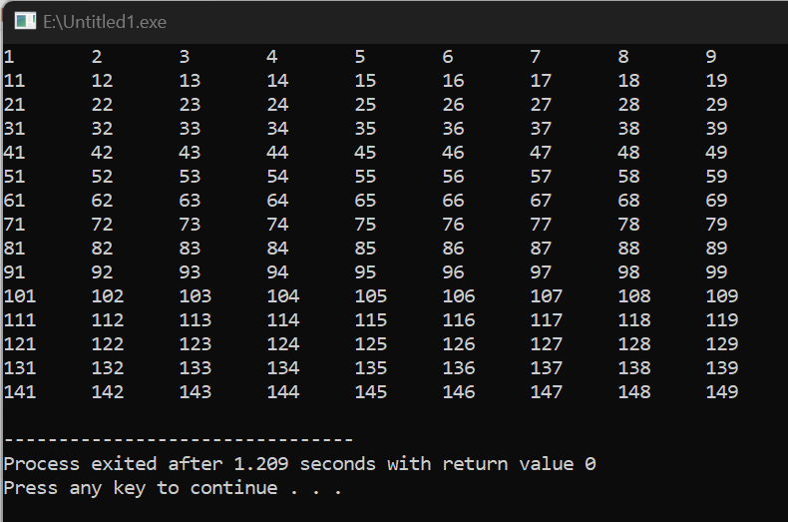

1. **Write a C++ program to find the sum of digits of a number.**

**The sum of digits means adding all the digits of any number, for example, we take any number like 358. Its sum of all digits is 3+5+8=16.**

#include<iostream>

using namespace std;

int main(){

int a,num,sum=0;

cout<<"Enter number :";

cin>>num;

do{

a=num%10;

sum=sum+a;

num=num/10;

}

while(num!=0);

cout<<"sum :"<<sum;

return 0;

}

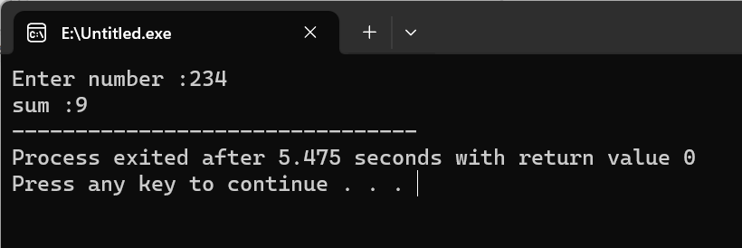

1. **Write a program in C++ to check whether a number is prime or not.**

#include <iostream>

using namespace std;

int main(){

int a,number,b=1;

cout<<"Enter number:";

cin>>number;

if (number==1){

cout<<"not a prime number";

}

else{

for(a=2;a<number;a++){

if(number%a==0){

b=2;

break;

}

}

if (b==2){

cout<<"Not a Prime number";

}

else{

cout<<"Prime number";

}

}

return 0;

}

